Kem Chan
CS360
Mar 17, 2026
Assignment 3-2: Android Studio Introduction

Android Studio Project, Setting up New Project
-name the project and include name in the title
-select Java as the language
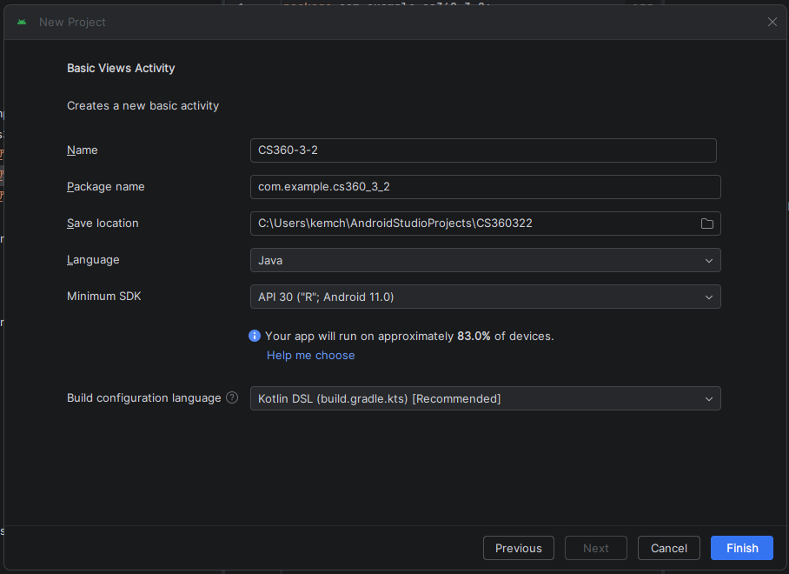

Open tabs
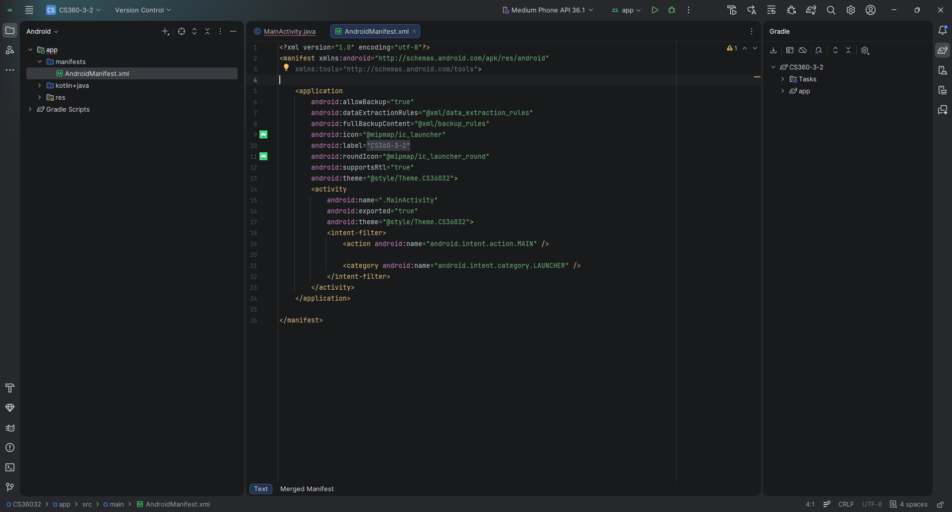

After opening activity_main.xml
-create new layout
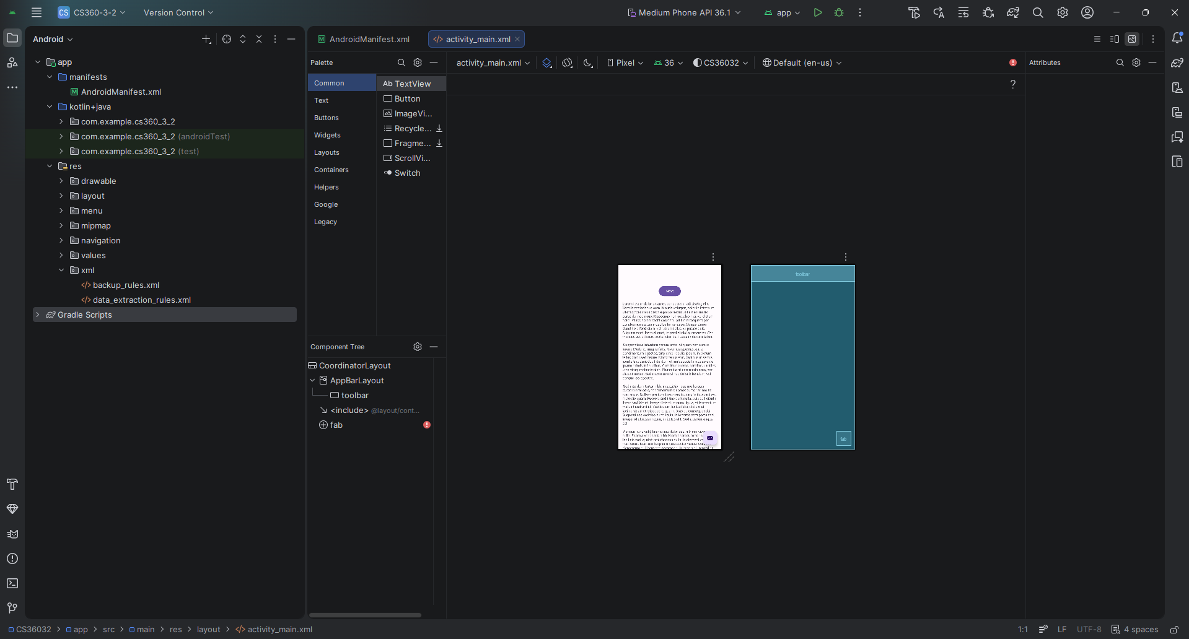
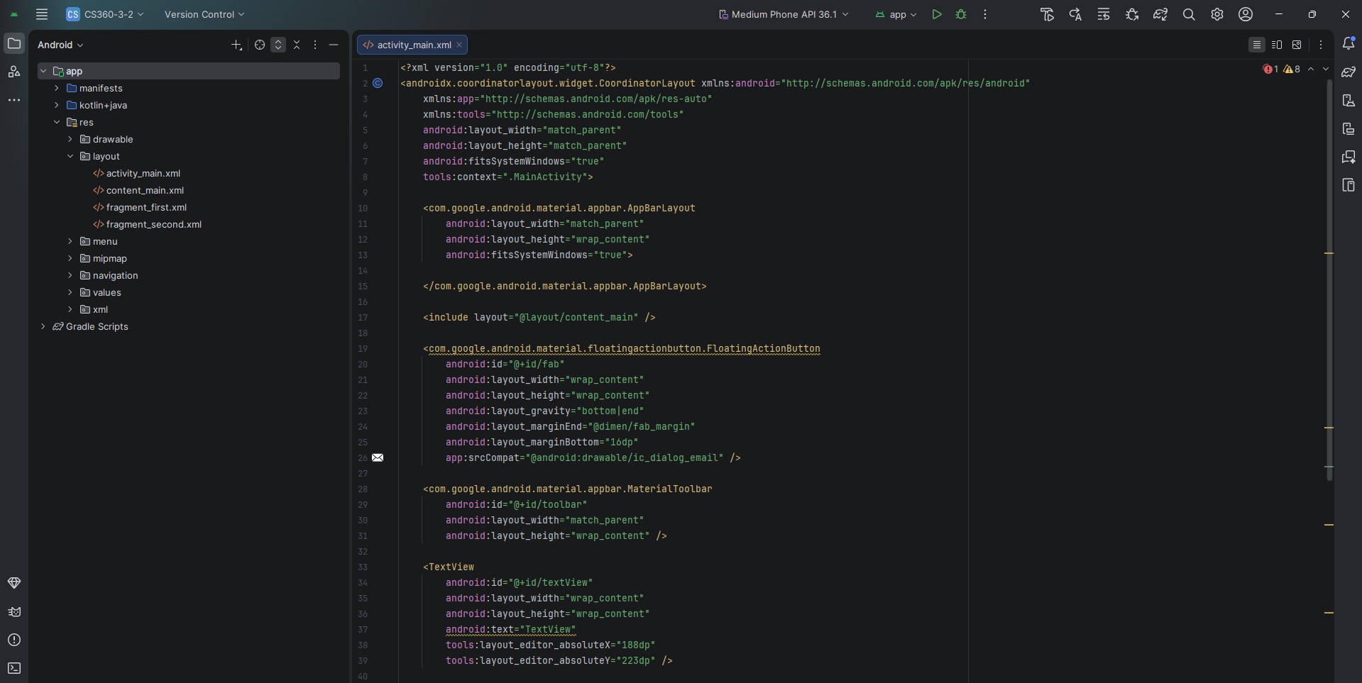
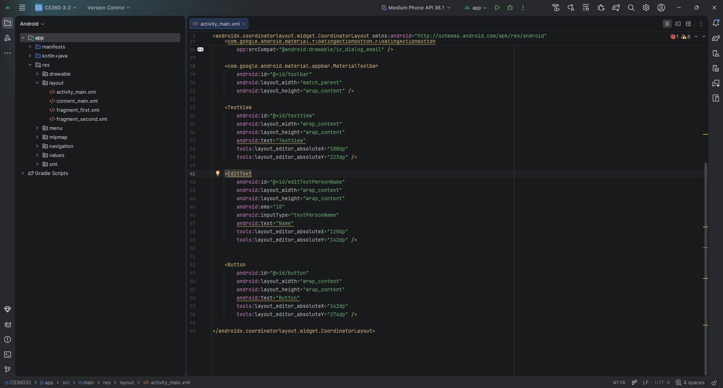

Android Studio Element
-name button text “say hello”
-remove all text from the text view
-label the ID of the button as “buttonSayHello”
-label the plain text as “nameText”
-label the TextView as “textGreeting”
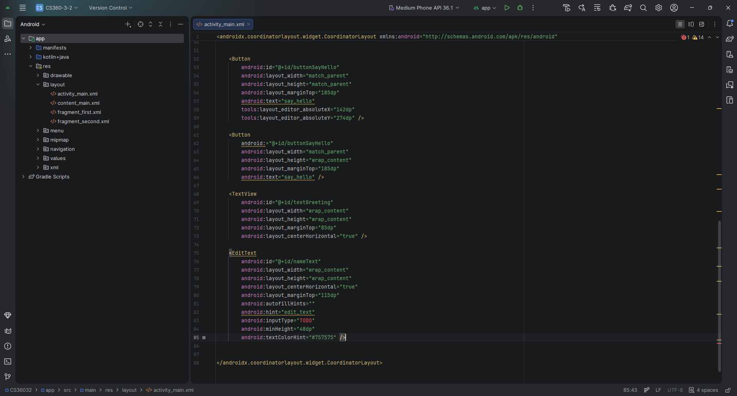

Working on this assignment felt very confusing, I tried following the guidelines for setting up an Android Studio Project since it was my first time working with this program. The instructions given mainly focus on the actual assignment and not the set up of the project making it a little bit more difficult without some sort of tutorial to properly set up the program. The major problem was enabling the “layout button” to move wherever it was desired on the screen rather than stacking up on the top left corner.
After some assistance from YouTube videos and Gemini to help me go through Android Studio resource directory by reformatting the directory. Adding the activity_main file to the layout folder was straight forward in inserting and connecting it to the resource of the directory. Once the set up of the activity_main file was as intended with the design option necessary, it allowed me to create the layout before touching any code initially and it took some time to register any changes if at all. The idea was to keep the design simple but adjusting the buttons and text to blend made it tricky because of how sensitive they were.
After messing with the software for a while I can appreciate the software and how it is designed to allow layout customizations to be more enjoyable and personalized in comparison to a script-based approach that would require debugging and is sensitive to the syntax.

